**Program Notes**

**Horde: The Game** is a digital video game that is controlled with sound by any number of improvising musicians simultaneously with the goal of earning as many points as possible within the time limit. Throughout the game, musicians are instructed to move an on-screen beetle around using musical gestures, notes, and other instrumental effects to explore the game board and collect orbs, other bugs which bestow power-ups upon you, moth allies, and avoid getting eaten by frogs. The controls and other elements evolve as the game progresses, and the score along with other game metrics are counted and displayed when the time limit ends.

**Technical Notes**

Horde: The Game uses a standalone Max program by which to play the game. The program contains instructions on how to set up, operate, rehearse, and finally perform the piece, although simply setting the desired time limit and pressing “Begin” is all that is needed to start the performance. Please email me for the application after purchasing, or if you have any questions directly at austinalexanderfranklin12@gmail.com. As for the technical requirements and equipment set up, please use the following configuration:

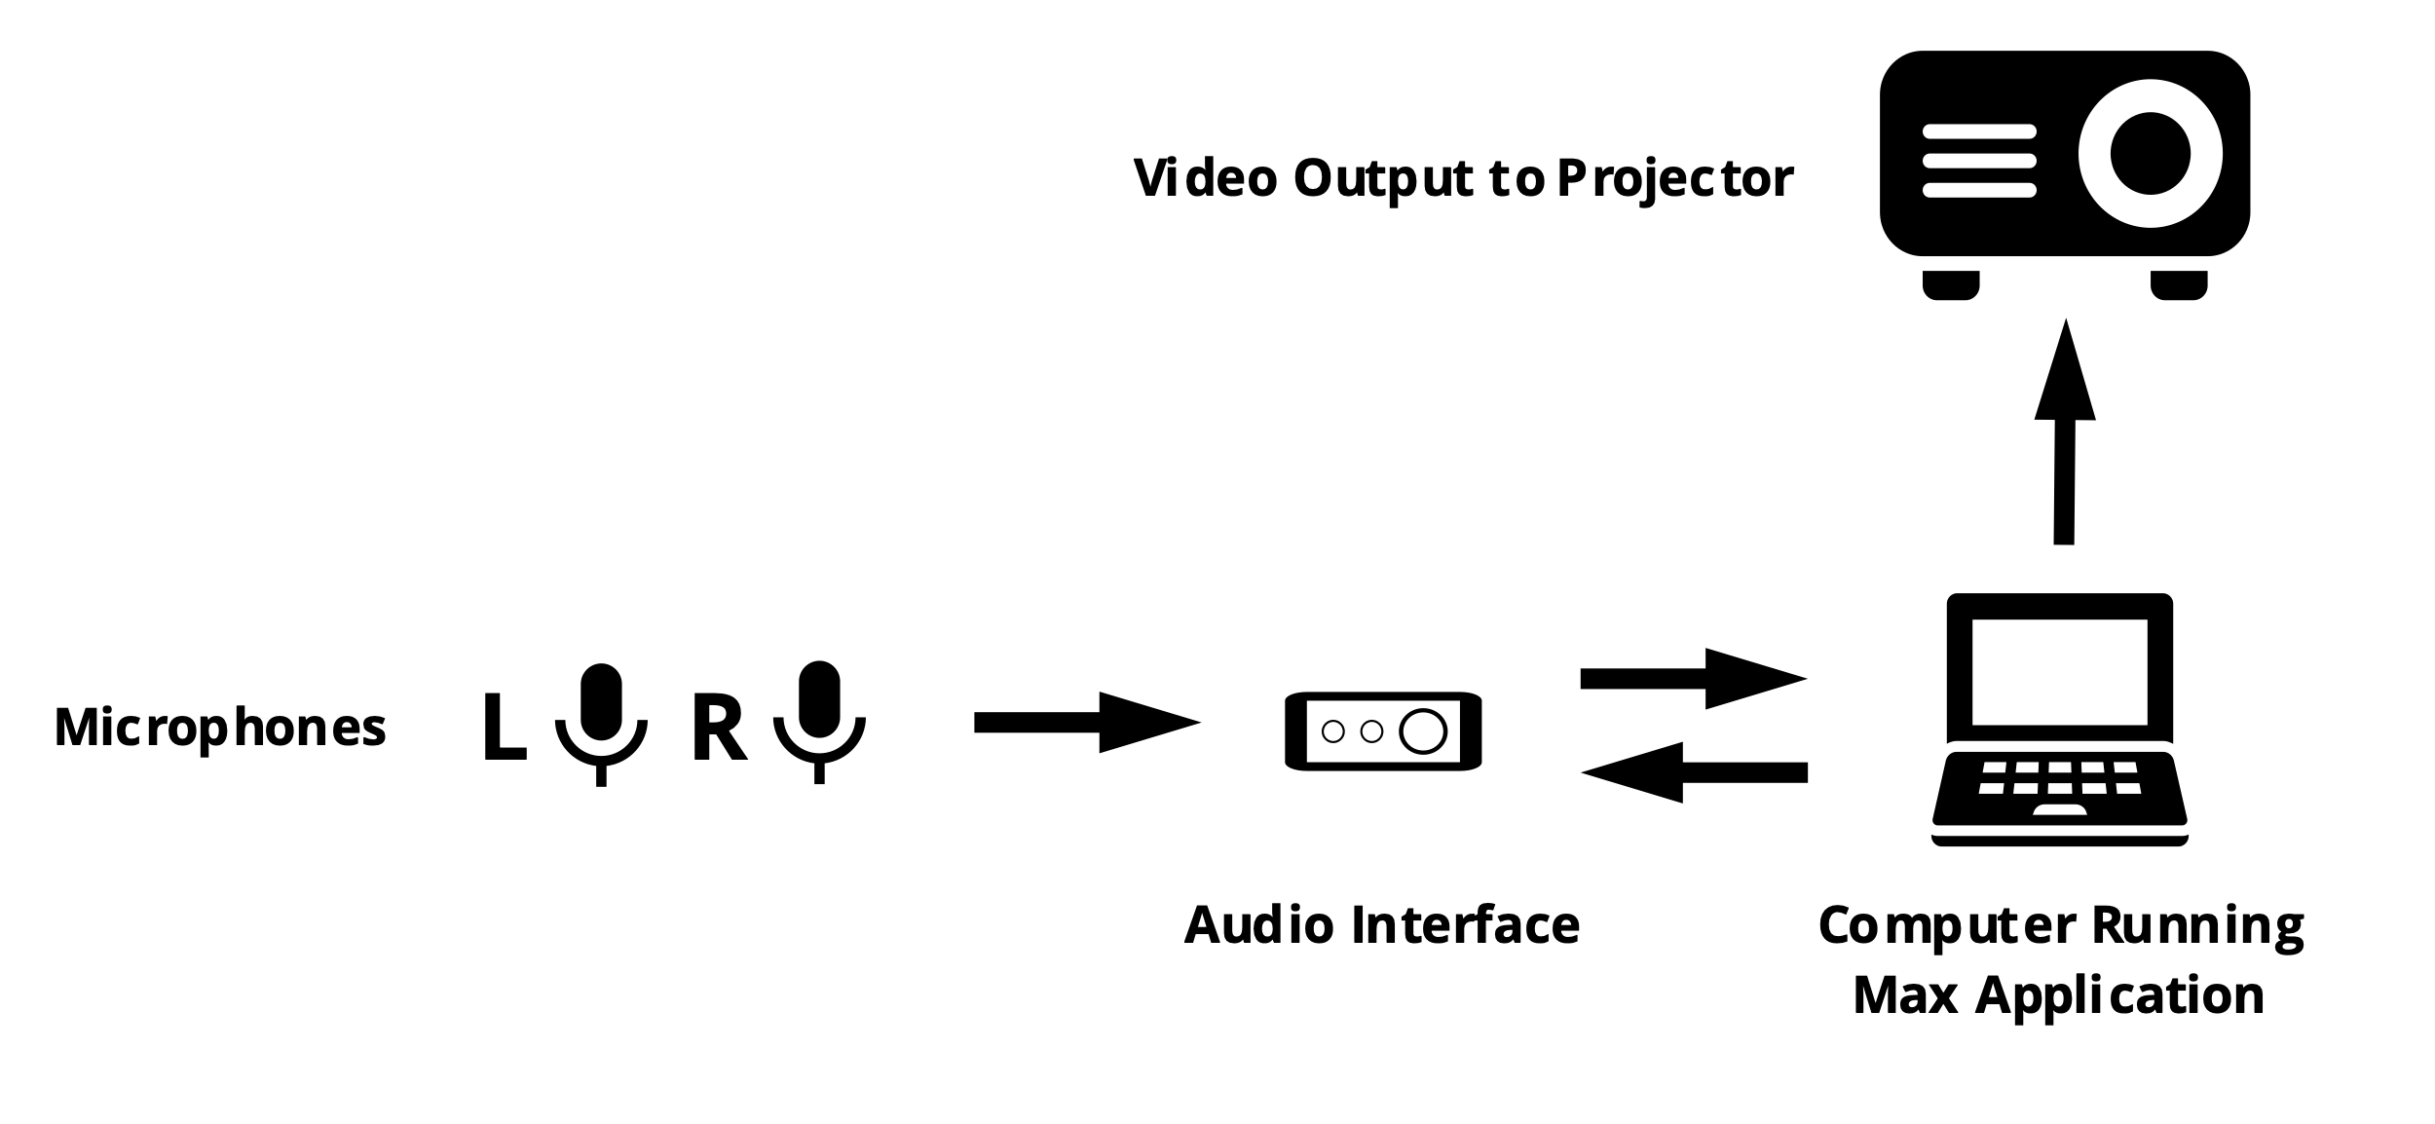

The game does not require amplification or playback. The only sounds during the performance are those that are made by the performers.

**Controls and Tips**

* Use the pitch classes located at the top, bottom, left, and right side of the screen to move the center beetle in that direction. The louder you play, the faster you move. However, the beetle slowly drifts during silence, so constant playing is not necessary.
* Use the noise and depth sliders at the bottom of the screen to control moth allies that you collect. Playing noisily on your instrument increases the noise slider while playing in a low register on your instrument increases the depth slider. These will make your allies spin faster and further out from the center, respectively. Anything your allies touch effects your center beetle. Use them to extend your reach.
* The BPM (beats per minute) indicator controls a variety of things on screen, mostly related to overall movement of game characters and mechanics. The enemies (frogs) move throughout the game and can be slowed by playing at a slower tempo. Playing with respect to a tempo is not necessary, but the BPM will continuously calculate regardless of whether you are playing at a constant tempo.
* There are several power-ups that make certain actions easier. The power-ups are growth, boost, teleport, anti-gravity, multiplier, and invincibility. The power-ups are other bugs that bestow their power upon you when you approach them.

**You Allies Enemies**

Duration: ca. 10-15’00”